WASHINGTON
COUNCIL
OF THE BLIND
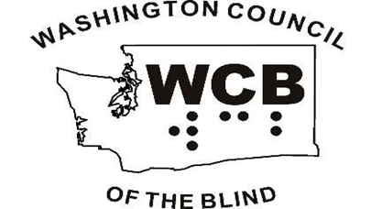
OPPORTUNITY
EQUALITY
INDEPENDENCE

PO Box 675
Yakima, WA 98907-0675

800-255-1147

info@wcbinfo.org
www.wcbinfo.org

Washington Council of the Blind (WCB) is a volunteer organization dedicated to promoting opportunity, equality, and independence within the blind community through education, public awareness, and advocacy.

WCB is a diverse state-wide consortium of local chapters committed to fostering lifestyles that reflect participation, productivity, independence, and dignity.

Affiliated with the American Council of the Blind (ACB), WCB is the largest organization of blind consumers in the state of Washington.

With no paid staff, the work of WCB is done by its membership through volunteerism. WCB is a 501(c)(3) non-profit organization. Your much-appreciated donations may be tax deductible, subject to guidelines established by the Internal Revenue Service.

CHAPTERS AND MEMBERSHIP

WCB welcomes blind, visually impaired and sighted individuals. There are chapters around the state, most of which meet monthly, and one state-wide affiliate, Guide Dog Users of Washington State.

Chapters advocate for the needs specific to their local communities and offer social activities and support. By paying nominal dues to the local chapter, individuals become members of WCB and ACB. At-large memberships are also available.

To locate a chapter in your area or learn about at-large membership, please call:

800-255-1147

Or visit

www.wcbinfo.org

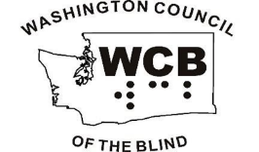

WCB PROGRAMS

Through active committees, WCB sponsors the following programs serving blind and visually impaired Washington residents:

• Information & Referral
• Advocacy & Legislation
• Scholarships & Loans
• Aging & Blindness
• WCB Families
• Crisis Assistance
• Annual Fall Convention
• Newsline, quarterly newsletter
• Educational and Leadership Programs
To learn more about any of these programs or to reach their appropriate contacts, please call: 800-255-1147 Or visit www.wcbinfo.org

MAKING A DIFFERENCE

In collaboration with others, WCB is responsible for:
Creating a separate state agency for the blind; passage of the Braille Bill that promotes Braille literacy for blind elementary and secondary school students; establishing the right for blind persons to be considered for jury service; and successful advocacy ensuring adequate funding levels for Washington state agencies serving the blind.

ANNUAL HIGHLIGHTS

Each fall the WCB state convention offers an opportunity to hear presentations addressing current issues of relevance to blind people and their families, learn about and examine new technology, and form life-long friendships. Throughout the year WCB conducts board meetings, leadership training, and other seminars aimed at educating its membership.
ADDITIONAL RESOURCES

[The following ACB logo is in the sans-serif Franklin Gothic font, using black print, since the brochure is black print on white paper. The letters ACB are on the left with the corresponding braille dots for each letter below. To the right of the letters is a line that divides the logo. To the right of the line American Council of the Blind is written out on two lines with the tagline “together for a bright future” underneath.]
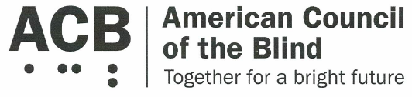
(WCB is an Affiliate of ACB)
202-467-5081
or 800-424-8666
www.acb.org

Hadley Institute
800-323-4238
www.hadley.edu

Northwest Access Fund
877-428-5116
www.nwaccessfund.org

WA State Department of
Services for the Blind

800-552-7103

www.dsb.wa.gov

WA State School
for the Blind
360-696-6321
www.wssb.wa.gov

WA Talking Book
& Braille Library
206-615-0400
or 800-542-0866
www.wtbbl.org WCB v.03-10-20

